Farzad Rahman

Software Engineer

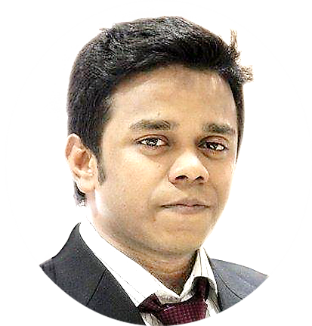

**Who I am**

**Name** Farzad Rahman

**Address** #H:18,#R:05,Nikunja 2,

Khilkhet

**Mobile** 01731893442

**E-mail** farzadrahman59@gmail.com

|  |  |
| --- | --- |
|  | /farzad.rahman |
|  |  |

**Objective**

To build up career at a responsible position in an organization where my talent and knowledge will significantly contributes to the organization’s target achievement and also capable of working in a challenging environment

Where I’ve worked

Tech Cloud Ltd.

Software Engineer

Develop Dynamic Websites for various national & international clients.

**2018-Till Date**

**Language Skills**

PHP

My SQL

HTML

CSS

Java Script

Bootstrap

Facebook Marketing

WordPress

PrestaShop



**Projects**

* [www.shamsersindex.com](http://www.shamsersindex.com/) (view my portfolios there)

And company related many works.









**Personal Skills**

Team Work

Time Keeping

Initiative

Organization

Hard Work

Communication

(Both in verbal and written)











**Where I’ve Studied**

University of Derby – England

B.Sc. in Information Technology

Appeared

Cambrian College, Dhaka

Higher Secondary School Certificate

CGPA: 4.90 on a 5 point scale.

Civil Aviation High School, Dhaka

Secondary School Certificate

CGPA: 5.00 on a 5 point scale.

**Extra Curriculum Activities**

* Vice president of Phoenix IT Club, BAC
* Story writing.

**2012-2015**

**Interests/Hobby**



**2009**

**2007**